**1)Information gathering using the Harvester:**

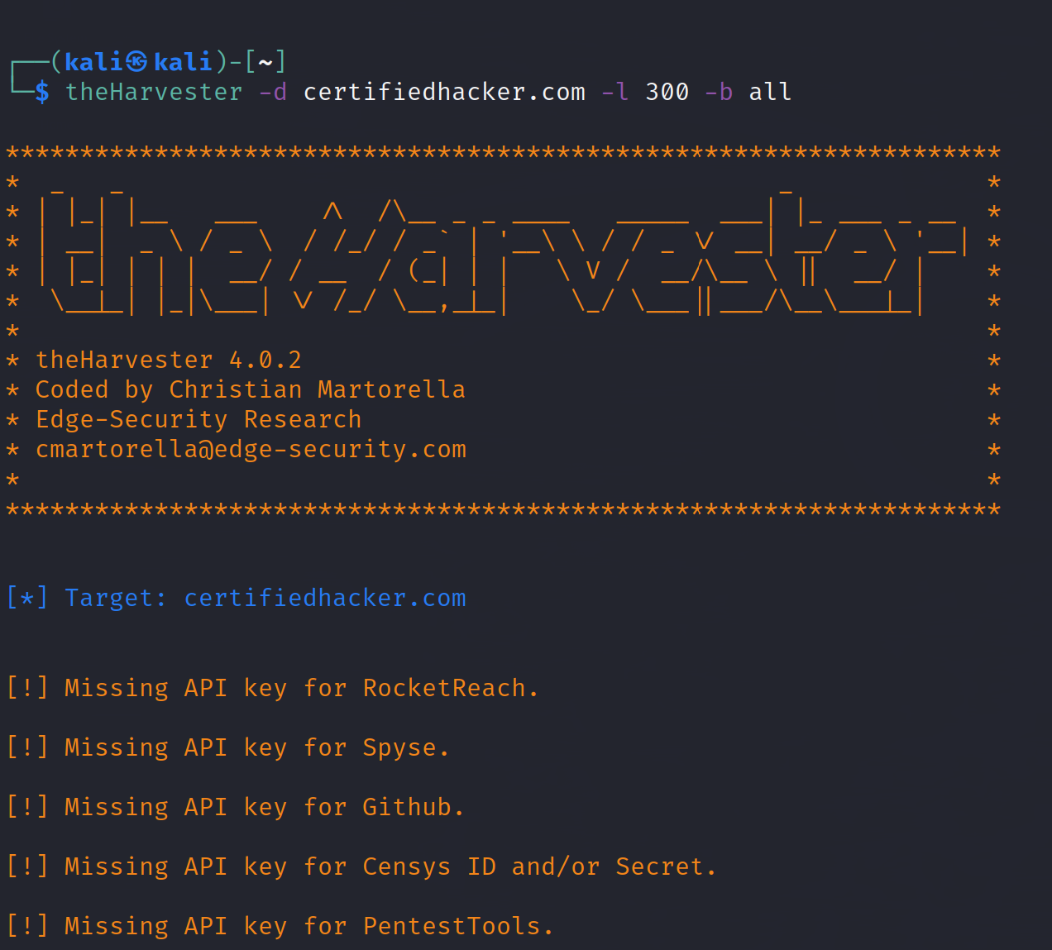

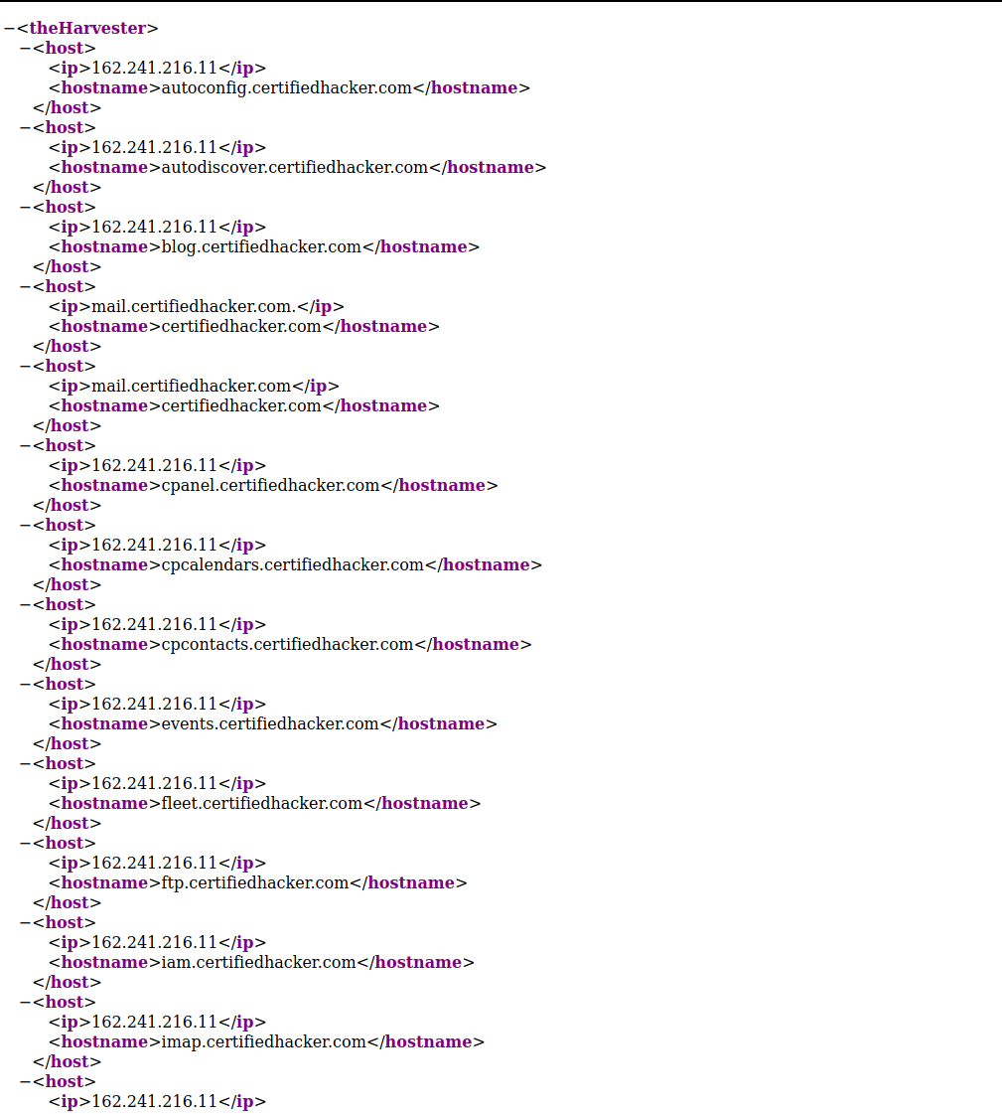

**2) Open Source Intelligence Gathering using OSR Framework:**

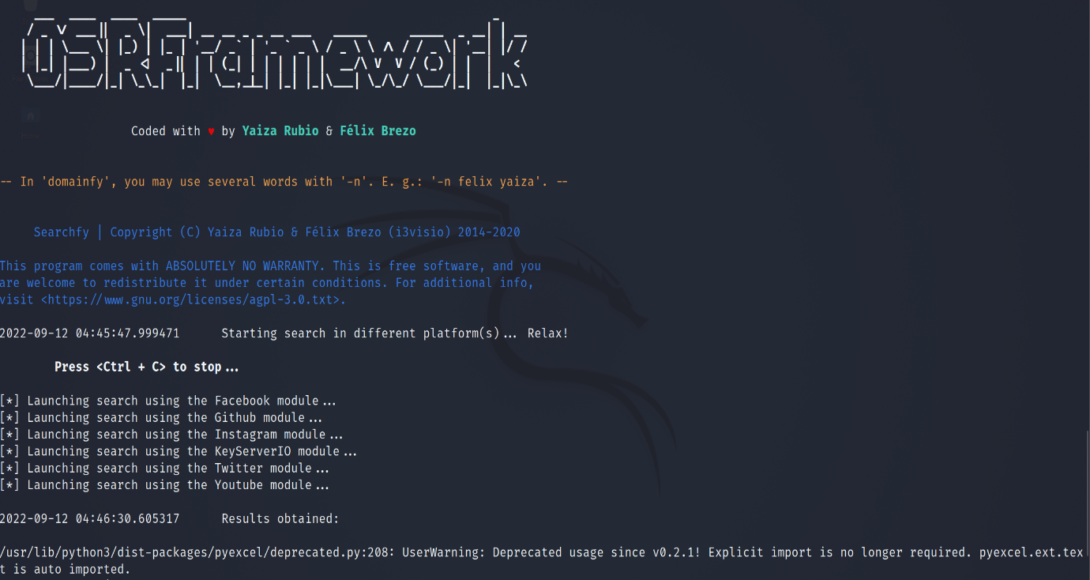

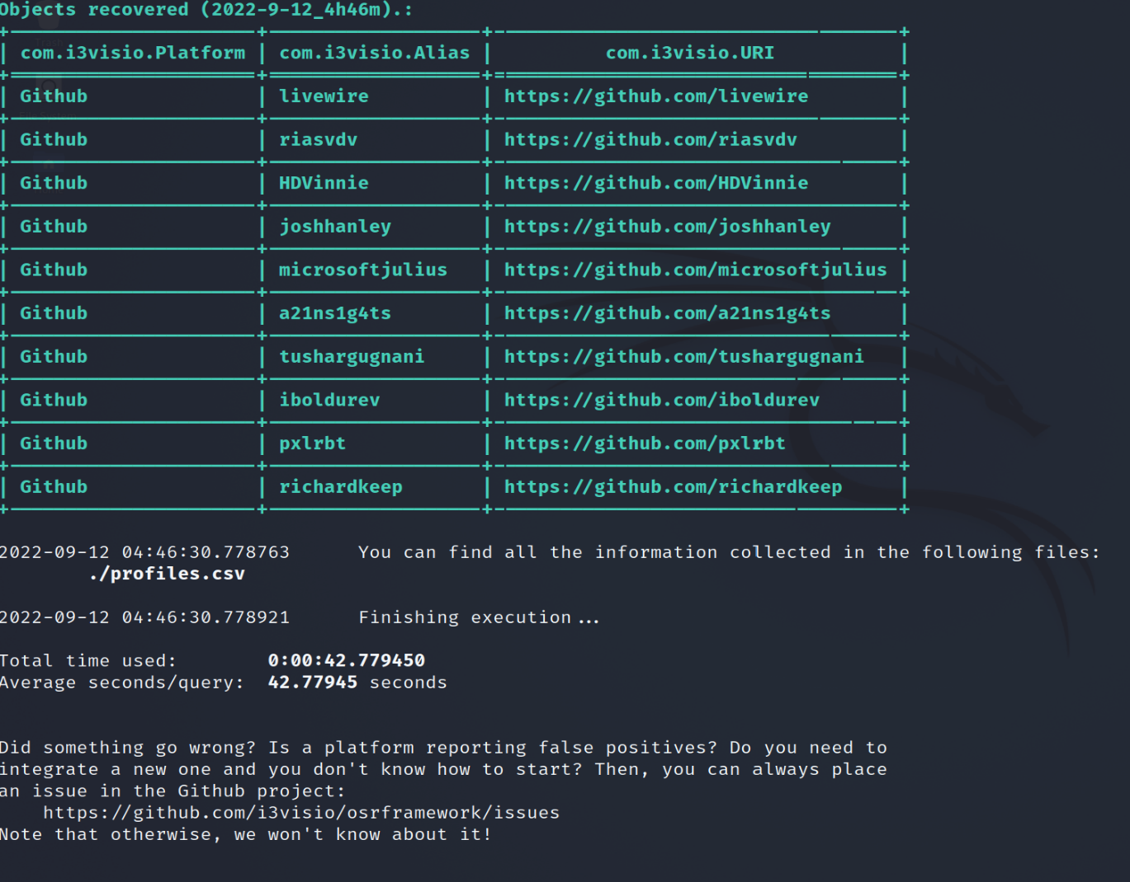

**3) Using who.is:**

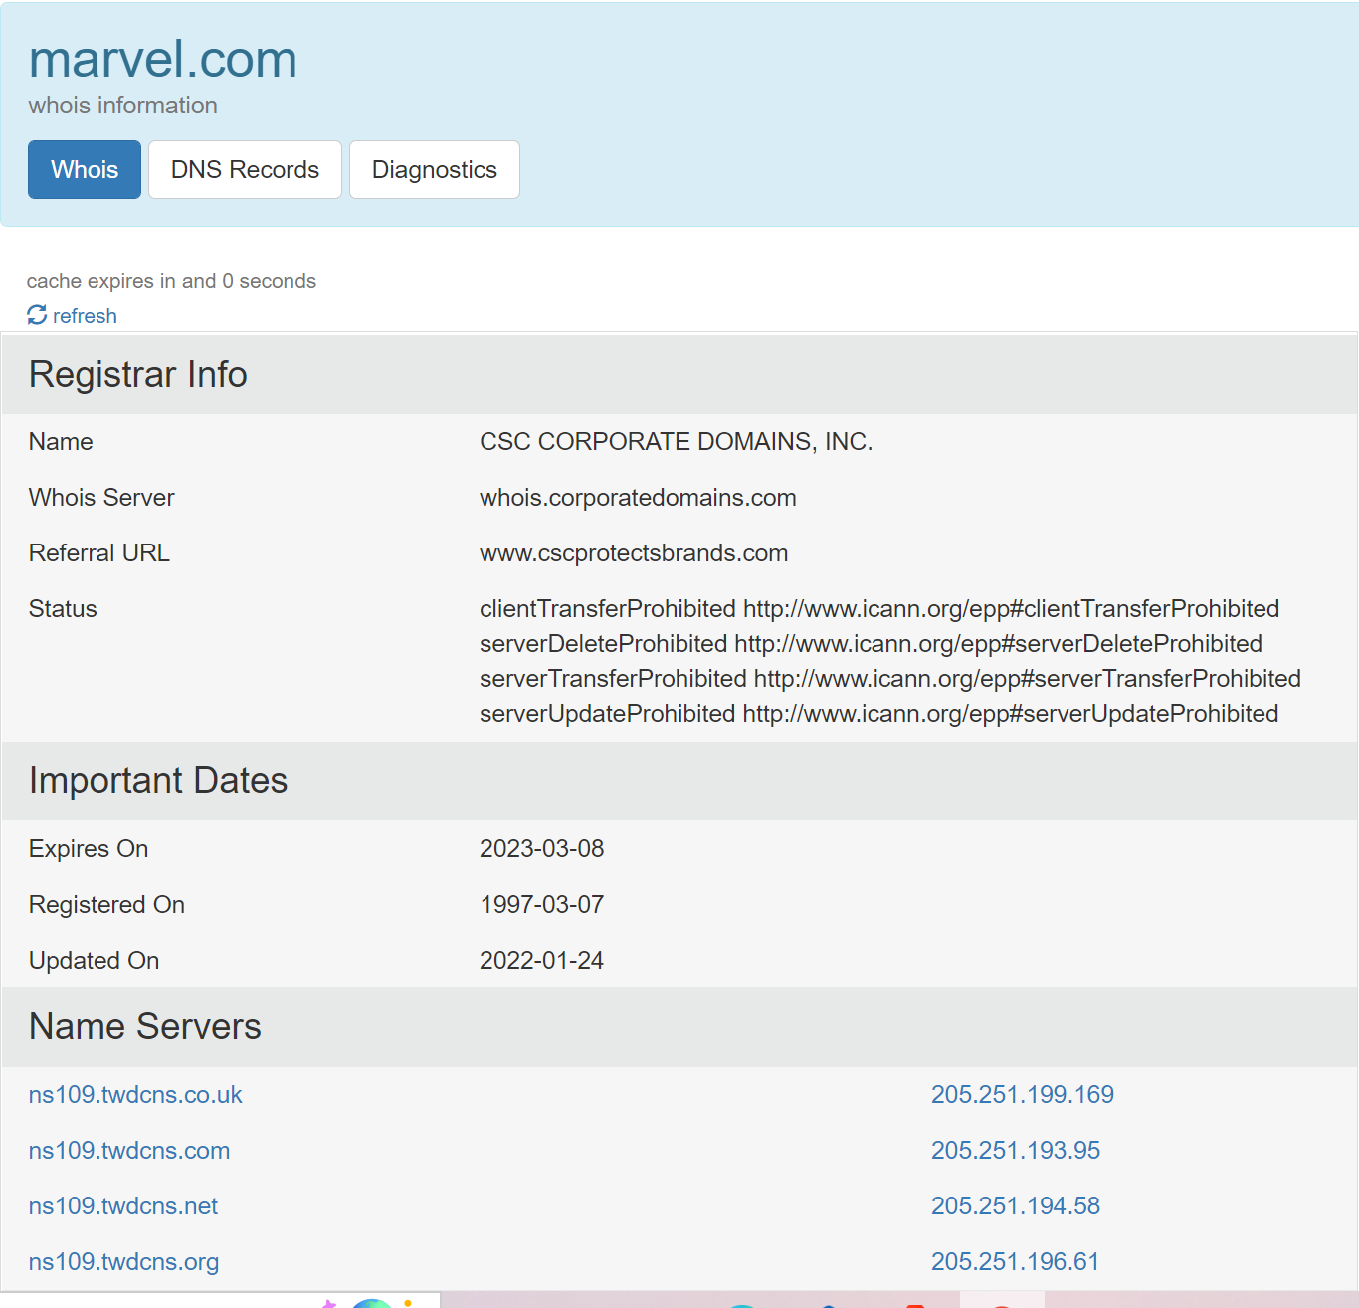

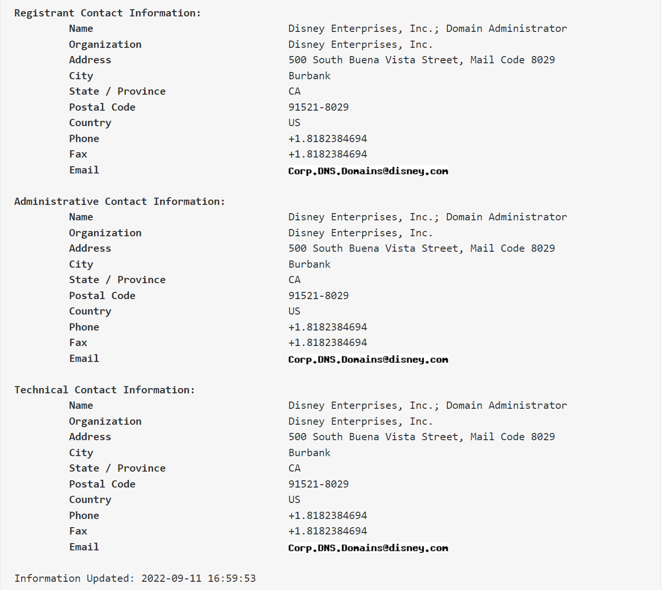

**4) Using Trace Route, ping, if config, netstat command:**

**Trace Route:**

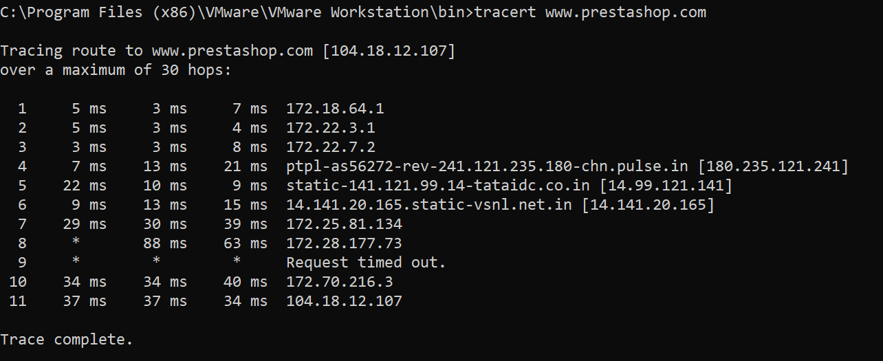

**Ping:**

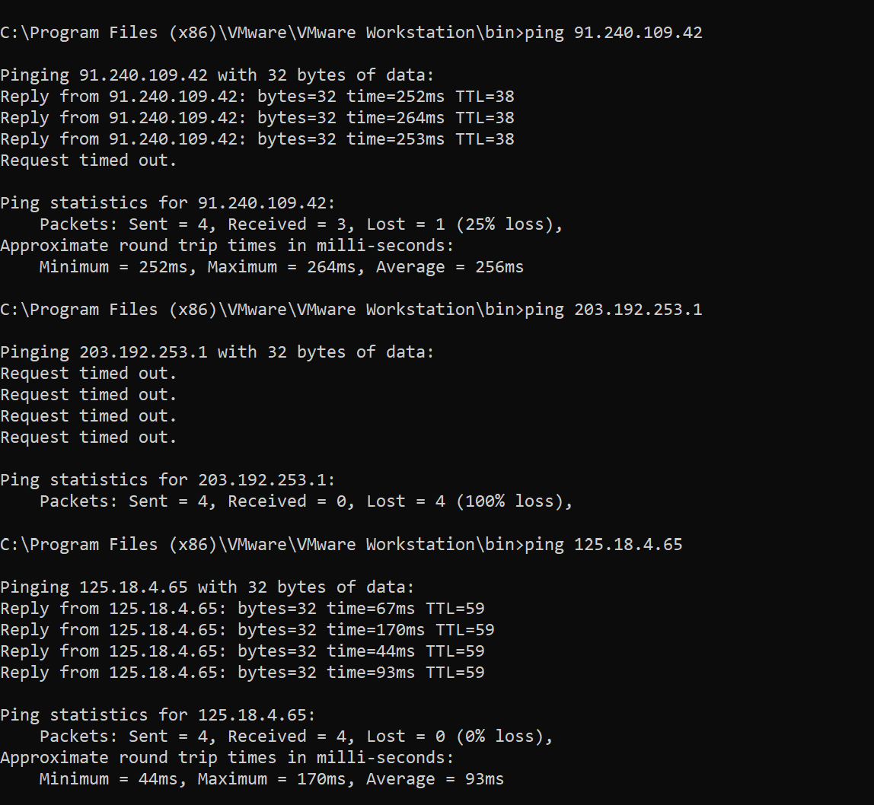

**If config:**

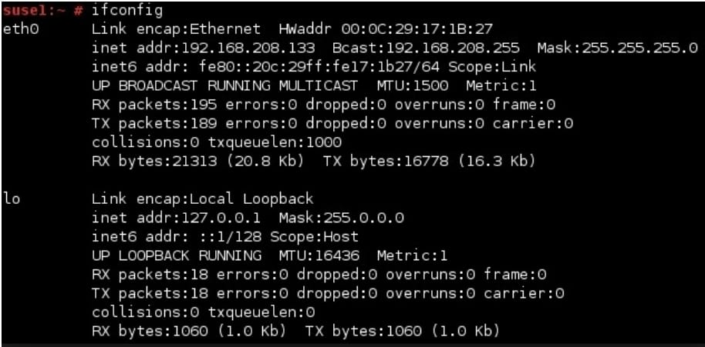

**Netstat:**

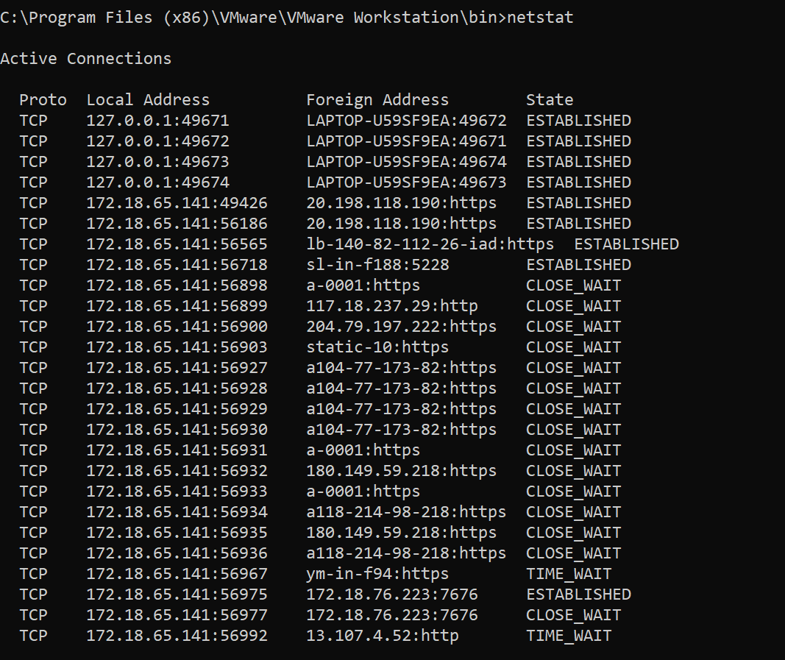

**5)** **Using Nmap Scanner to perform port scanning** :

**Ack:**

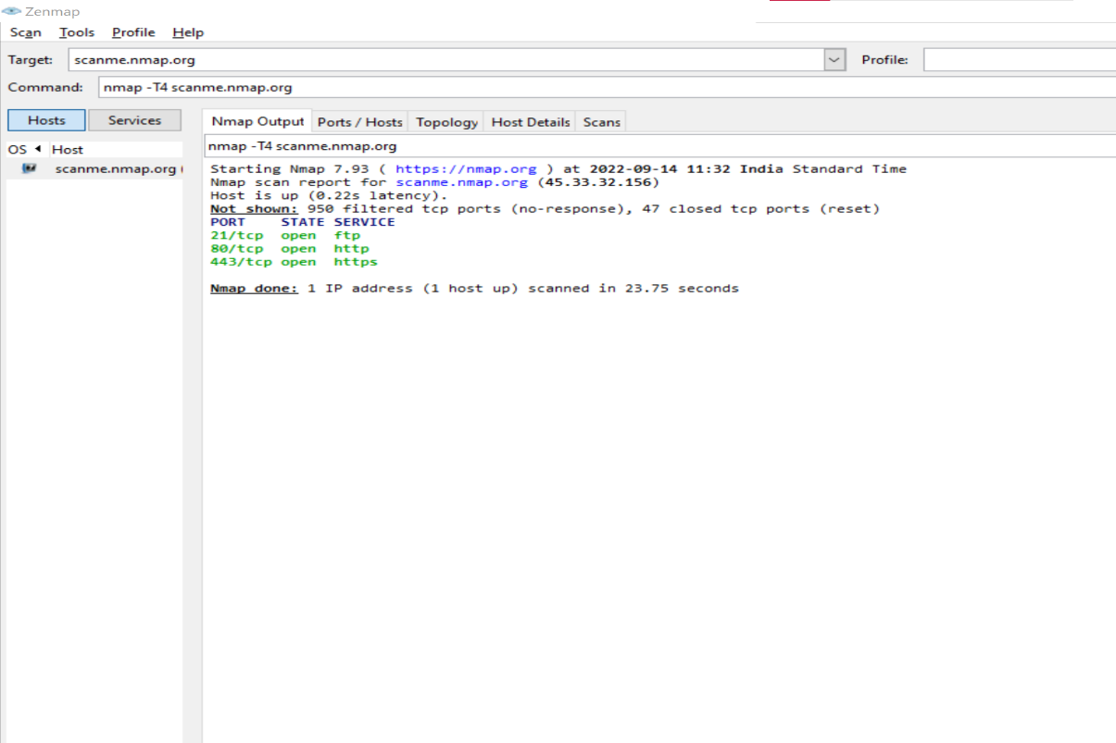

**SYN:**

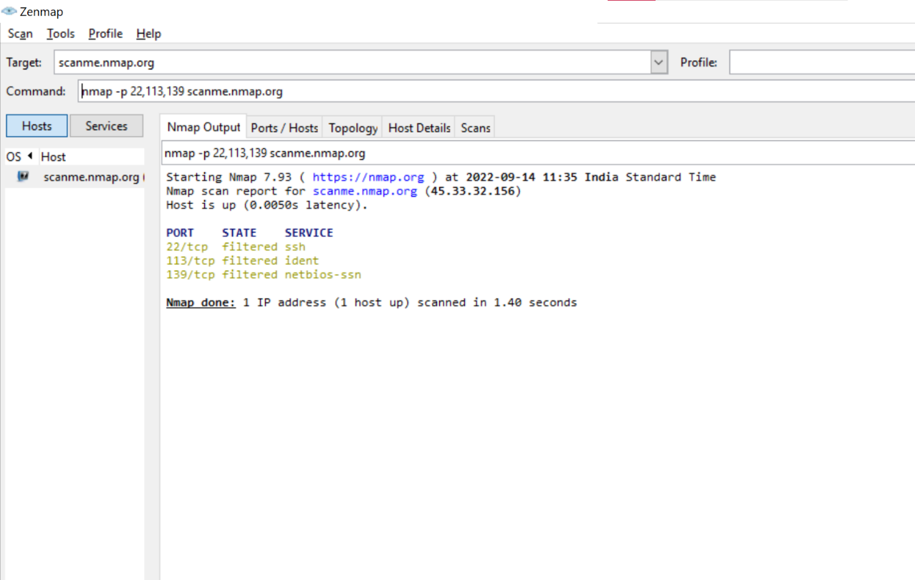

**FIN Scan:**

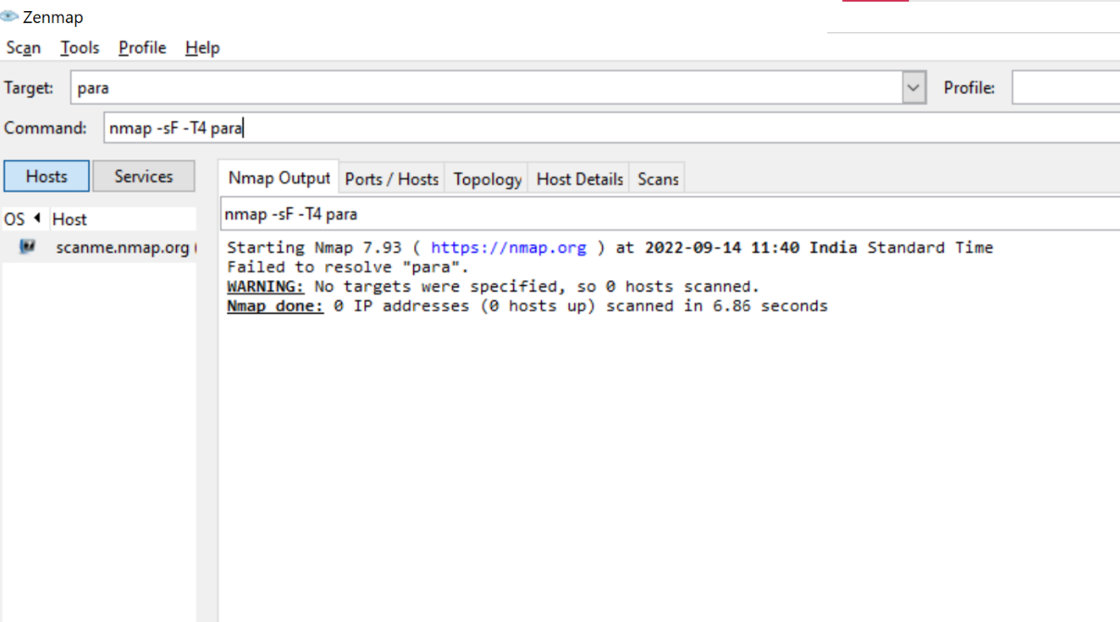

**NULL Scan:**

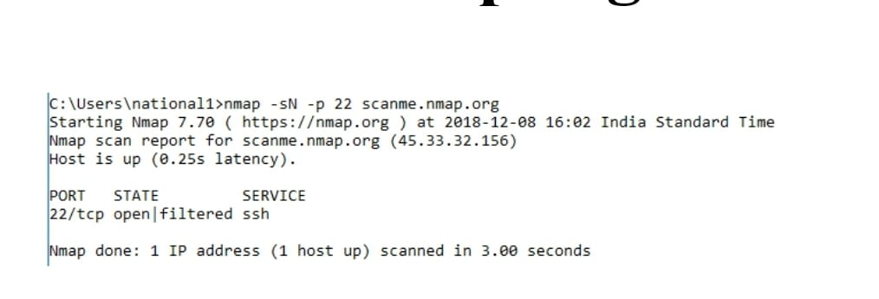

**X Mas Scan:**

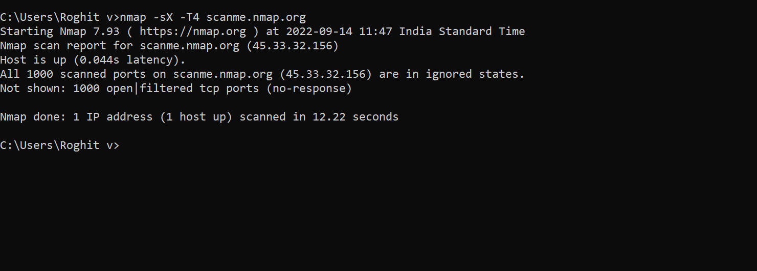

**6) Use WireShark sniffer to capture network traffic:**

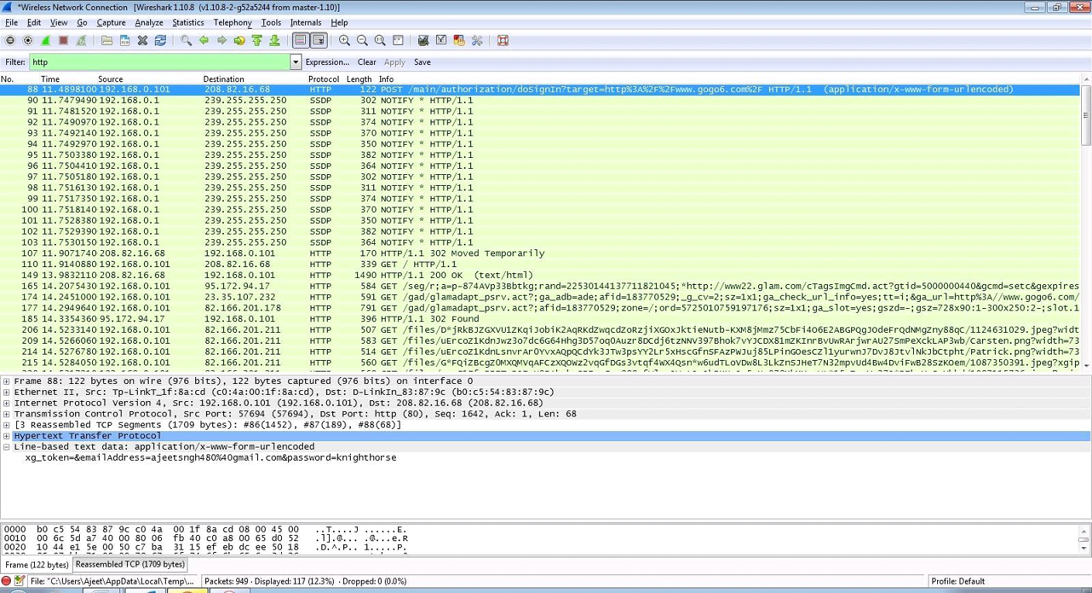

**7) Create a simple keylogger using python code:**

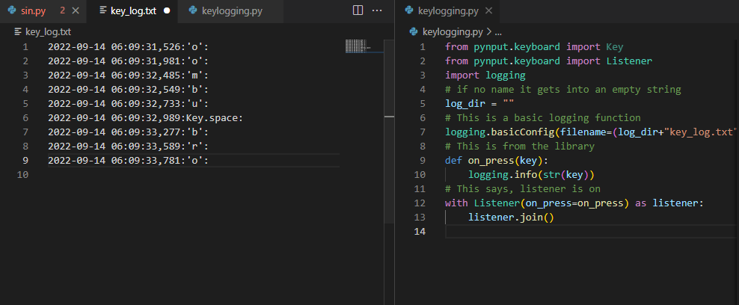

**8) Scanning Network-Daisy chaining using proxy workbench:**

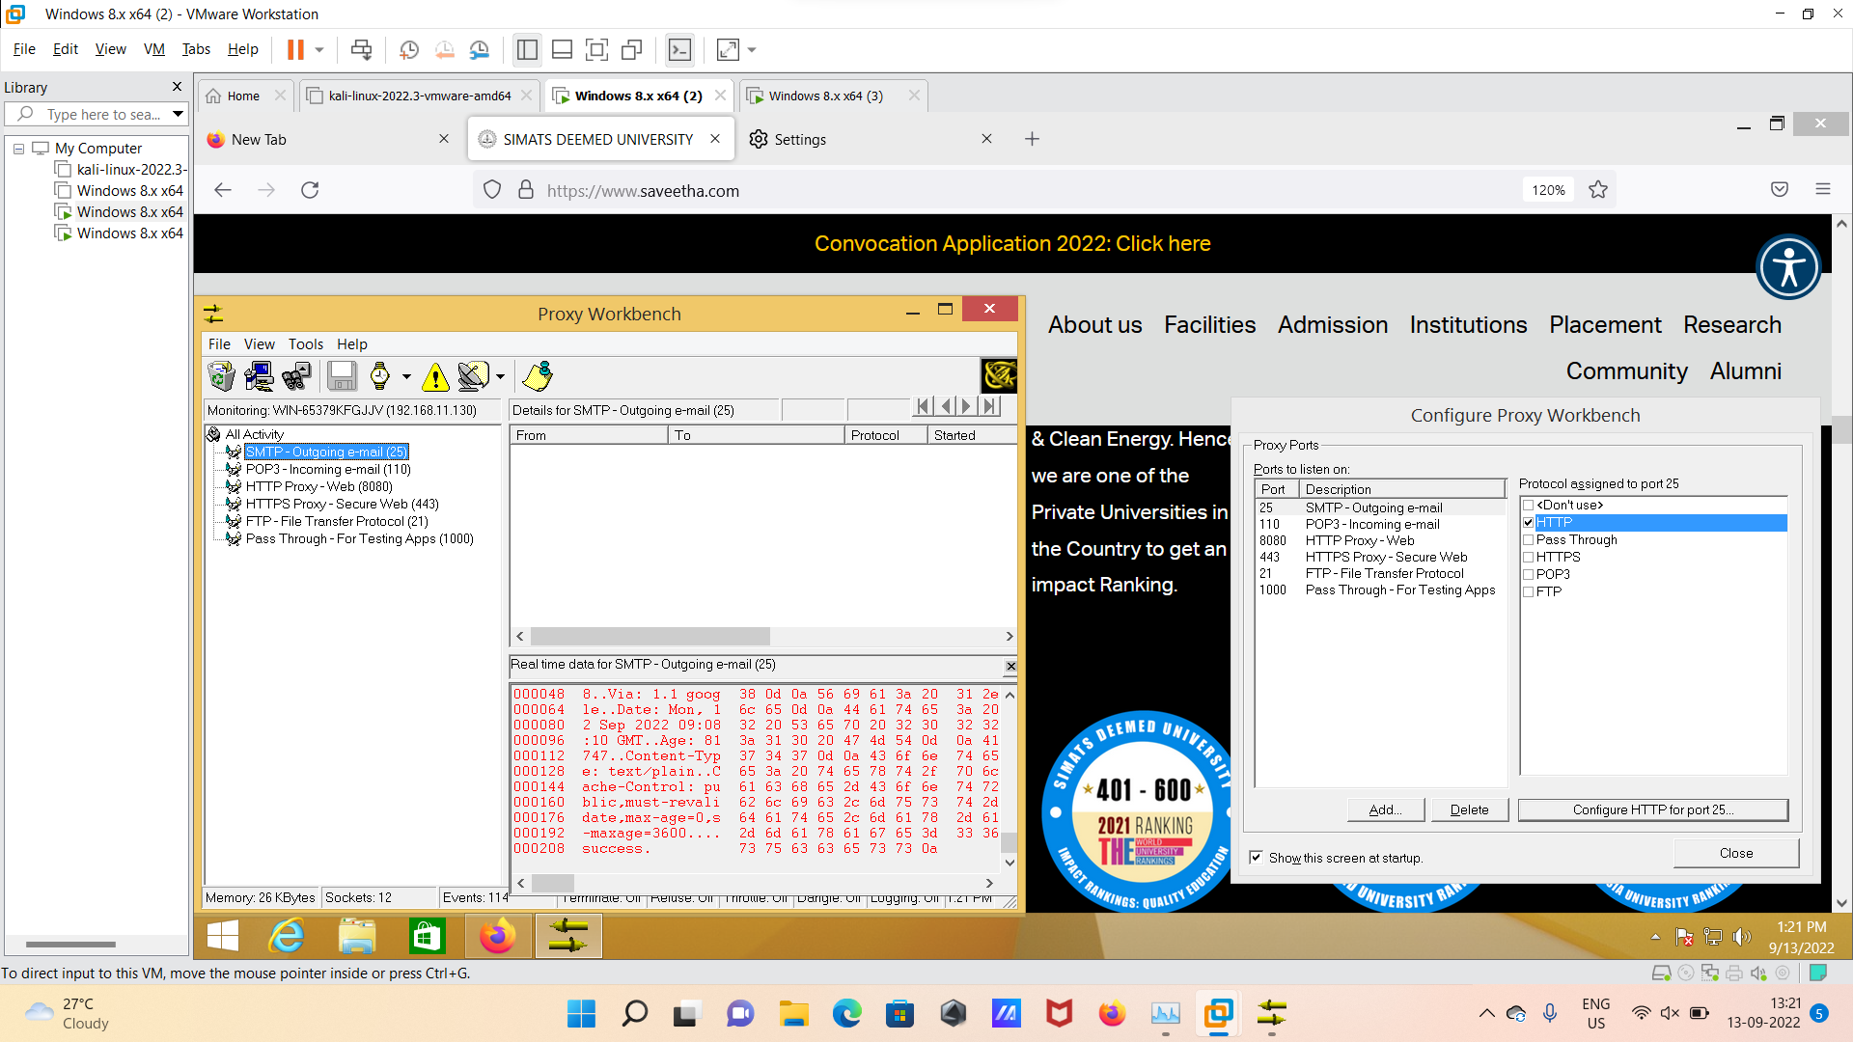

**9) ENUMERATION:**

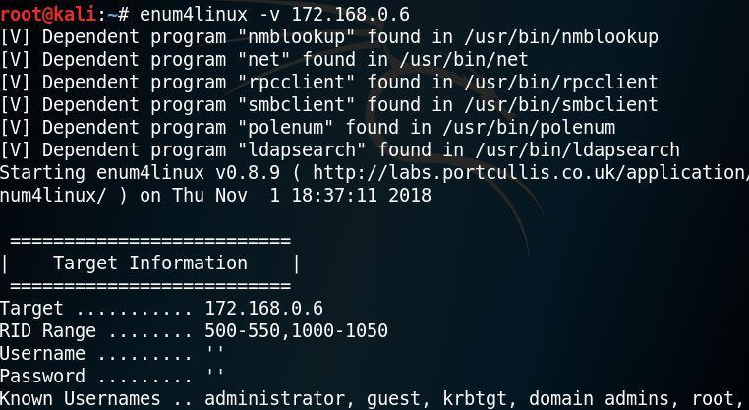

**10) MALWARE THREATS:**

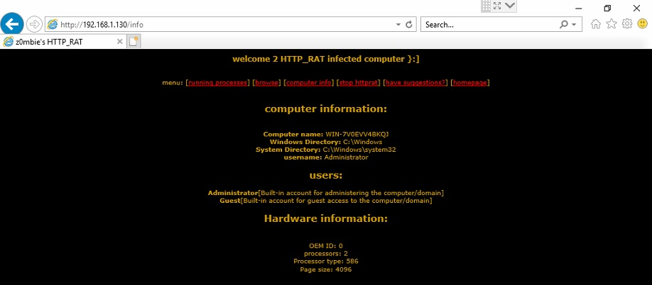

**11) Virus Analysis using OllyDbg:**

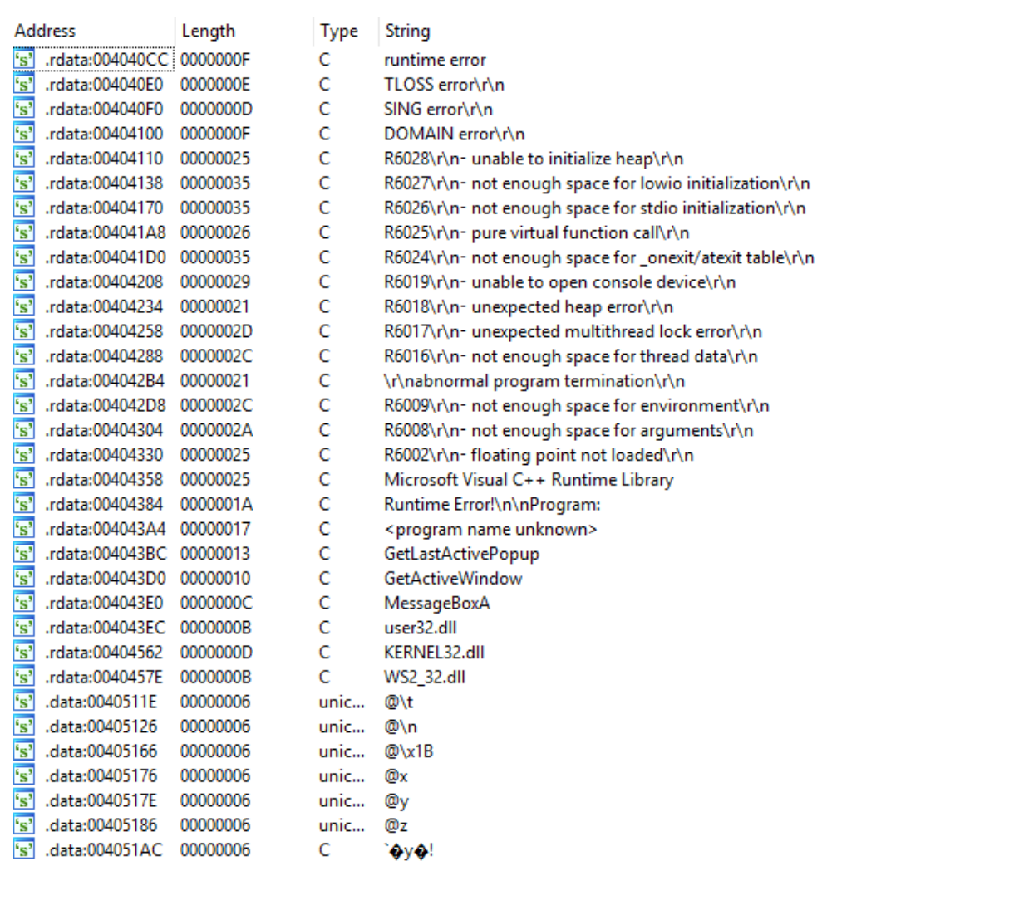

**12) Image Steganography using QuickStego:**

**Before image:**



**After image:**



**13) System Hacking Active online Attack using Responder:**

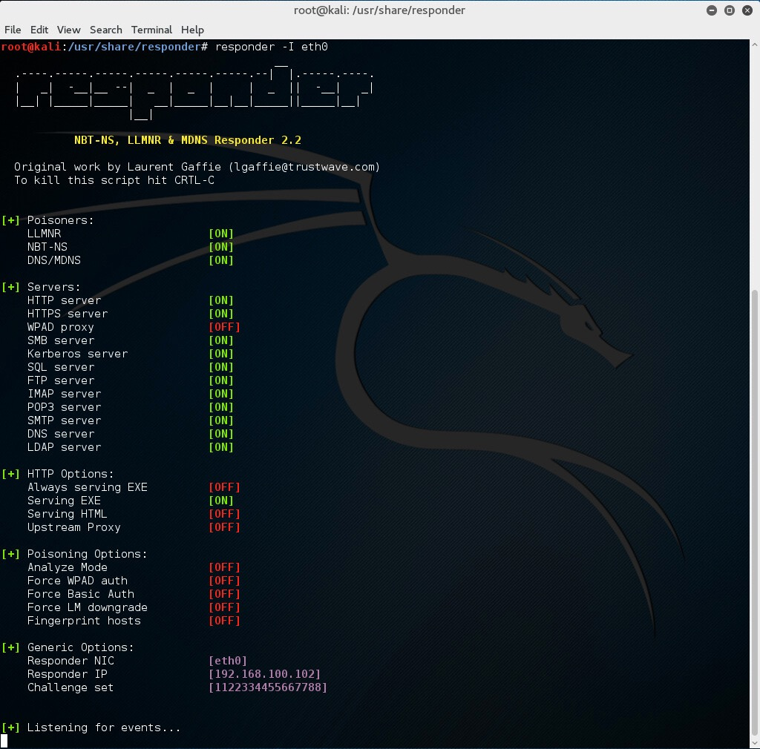

**14) Foot-printing a Target using Malte-go:**

